Fajr Prayer – Morning Prayer 2 Rakah
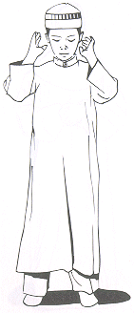
Start with Intention

“Alla-hu Akbar”
“Subhana Kal-lah hum-ma wabi hamdika wata-bara kasmuka
wata'ala jad-duka wala ilaha ghyruka.

A'uzu bil-lahi minash Shayta-nir-rajeem”

Start Rakah
“Bismillah hir-Rahman ir-Raheem”

Surah Fatiha
“Alhamdul lil-lahi rab-bil 'alameen
Ar rahma nir-raheem
Maliki yawmid-deen
Iyyaka na'budu wa iyyaka nasta'een
Ihdinas siratal mustaqeem
Siratal Lazeena an'amta 'alayhim
Ghai-ril maghdubi 'alayhim
Walad dal-leen. Ameen”

Surah Ikhlas
“Qul huwal lahu ahad.
Allah hus-Samad.
Lam yalid walam yulad.
Walam yakul-lahu Kufuwan ahad.”
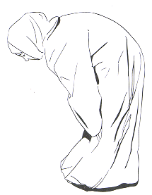
“Alla-hu Akbar”

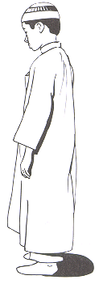
Supplication in Ruku (Vowing)
“Sub-hana Rabbi-al 'azeem”. X 3

Qawmah (Standing After Ruku)
“Sami 'allah hu liman hamida. Rab-bana lakal hamd.”

“Alla-hu Akbar”
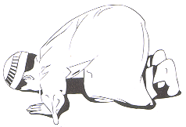
First Sajdah (Prostration)
“Sub-hana Rabbi yal a'la” X 3

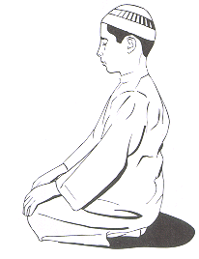
Jalsah (Sitting between two Sajdah)
Alla-hu Akbar. Sit for a short while and recite the following:
Allah hum maghfirlee war-ham nee

“Alla-hu Akbar”
Second Sajdah
“Sub-hana Rabbi yal a'la” X 3

“Alla-hu Akbar”
Start Rakah
“A'uzu bil-lahi minash Shayta-nir-rajeem

Bismillah hir-Rahman ir-Raheem”

Surah Fatiha
“Alhamdul lil-lahi rab-bil 'alameen
Ar rahma nir-raheem
Maliki yawmid-deen
Iyyaka na'budu wa iyyaka nasta'een
Ihdinas siratal mustaqeem
Siratal Lazeena an'amta 'alayhim
Ghai-ril maghdubi 'alayhim
Walad dal-leen. Ameen”

Surah Al-Kawthar
“Inna aAAtaynaka alkawthar
Fasalli lirabbika wainhar
Inna shani-aka huwa al-abtar”
“Alla-hu Akbar”
Supplication in Ruku (Vowing)
“Sub-hana Rabbi-al 'azeem”. X 3

Qawmah (Standing After Ruku)
“Sami 'allah hu liman hamida. Rab-bana lakal hamd.”
“Alla-hu Akbar”
First Sajdah (Prostration)
“Sub-hana Rabbi yal a'la” X 3
Jalsah (Sitting between two Sajdah)

“Alla-hu Akbar”.
“Allah hum maghfirlee war-ham nee”

“Alla-hu Akbar”
Second Sajdah
“Sub-hana Rabbi yal a'la” X 3

“Alla-hu Akbar”
Tashahud
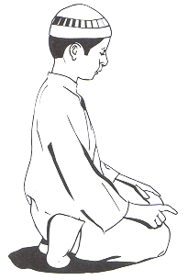
“At-tahiy-yatu lil-lahi was sala-watu wat-tay yibatu
As-salamu 'alayka ay-yuhan-nabiy-yu
wa rahma tullahi wa bara-katuhu
As-salamu 'alayna wa'ala 'ibadil-la his-sali-heen
Ash hadu al-la ilaha il-lal lahu
wa ash hadu an-na Muhammadan
'ab-duhu wa rasuluh.”

Salat Alan-Nabi (Darud) - Salutation to the Prophet
“Allah humma sal-li 'ala Muhammadin
wa 'ala ali Muhammadin,
Kama sal-layta 'ala Ibraheema
Wa'ala ali Ibraheema
innaka Hameedum Majeed
Allah humma barik 'ala Muhammadin
wa 'ala ali Muhammadin,
Kama barakta 'ala Ibraheema
Wa 'ala ali Ibraheema
innaka Hameedum Majeed”.
After Salat Alan-Nabi, recite the following:
“Rab bij'alnee muqeemas salati wa min
zur-riy yatee rab-bana wata qab-bal du'a,
rab-ba nagh-firlee wali waliday-ya
wa lil mu-mineena yawma yaqumul hisab”.

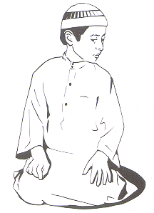
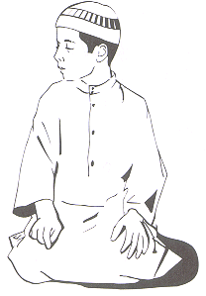
Look towards your right shoulder and say it once then look towards your left shoulder and say it once again.
“As-salamu 'alaykum wa rah-matul lah”

Right First
Then Left

